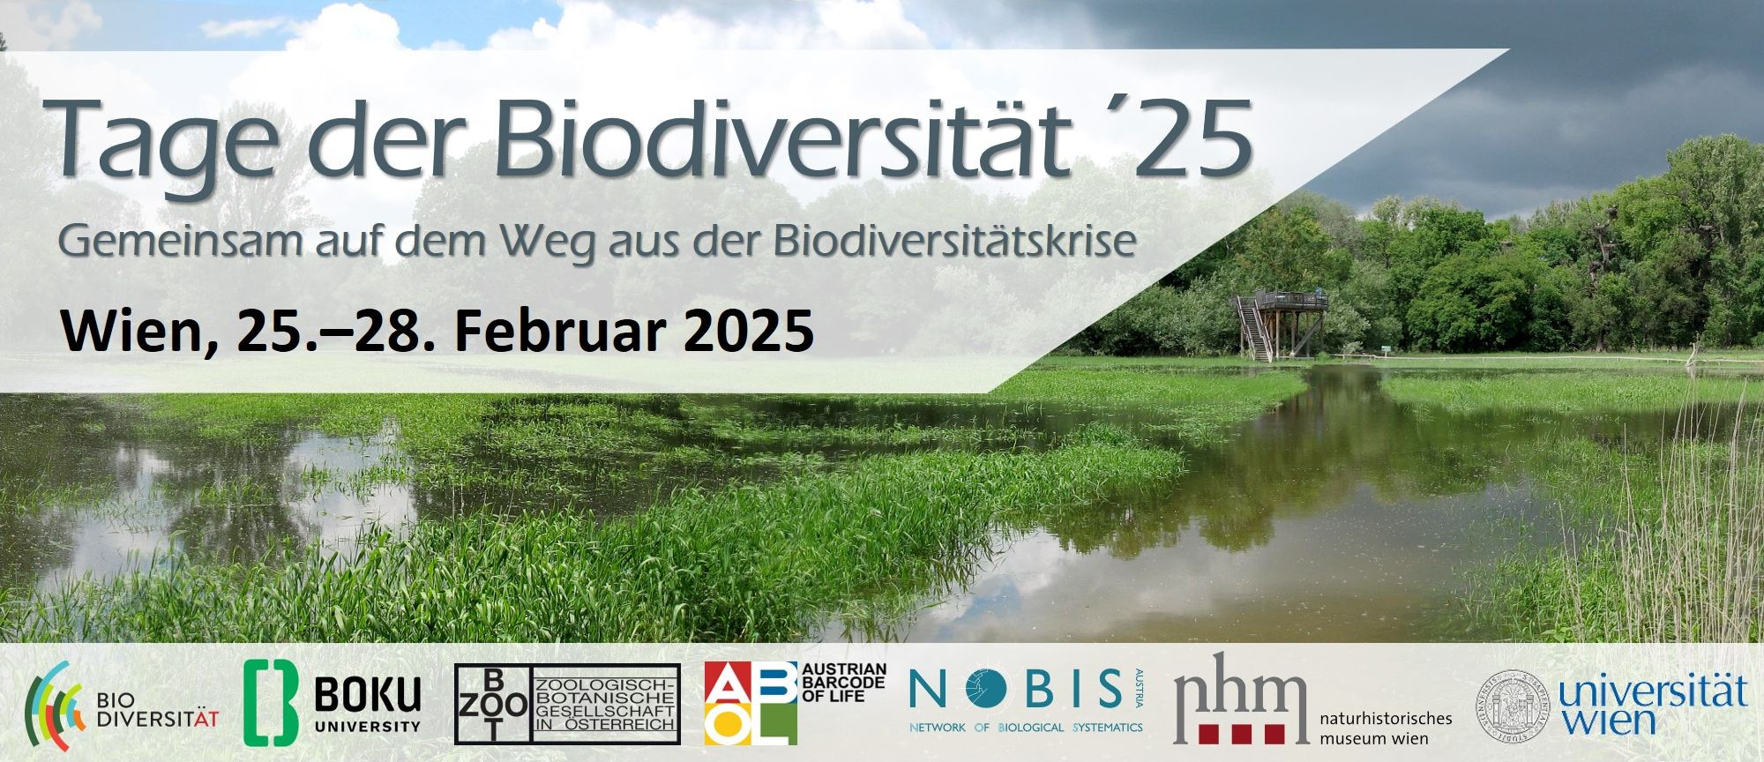

Call for Abstracts
Kontakt/Contact:
Name: …………………………………………………………………………………………………………………………………………………………………….………………………………….
Tel.: ……………………………………………………………………………………………………………………………………………………………………………………………………………..
E-Mail: ……………………………………………………………………………………………………………………………………………………….………………………………………………
Institution: ……………………………………………………………………………………………………………………………………………………………………………………………..

Bitte Zutreffendes ankreuzen / please tick as appropriate:
- Ich möchte in folgender Session (Session-Nummer) präsentieren / I would like to present in the following session (session no.): ……………………………………………………………………………………………………………………………………………………………………..
- Ich möchte in folgendem Workshop (Workshop-Nummer) präsentieren / I would like to present in the following workshop (workshop no.): …………………………..……………………………………………….…………………………………………………………..
- ☐ Vortrag/talk ☐ Poster/poster
Für Bewerber:innen zum Biodiversitätspreis/ for competitors for the Biodiversity Prize of the Young Researchers‘ Session No. 2.3:
- Ich bewerbe mich in der Kategorie / I am competing in the category:
☐ MSc ☐ PhD ☐ Trifft nicht zu/does not apply

Bitte schicken Sie Ihr Abstract bis 15.12.2024 an office@biodiversityaustria.at / Please send your abstract to office@biodiversityaustria.at. Deadline is Dec, 15th, 2024.
Bitte nehmen Sie zur Kenntnis, dass die Tagungssprache DEUTSCH ist. In begründeten Ausnahmen ist auch Englisch möglich. / Please note that the language of the conference is GERMAN, talks/posters in English are possible in justified exceptions.
Abstract Form
Title 16 points Arial, left-justified

Author, A.¹, Author, B. ² & Author, C. ^{1,3} (12 points, Arial, left-justified)

¹ Department, Institution, Ort/City, Land/Country, Email: xxxx@xxxxxx (10 points, Arial, left-justified)
² Department, Institution, Ort/City, Land/Country (10 points, Arial, left-justified)
³ Department, Institution, Ort/City, Land/Country (10 points, Arial, left-justified)

Text: 10 points; Arial, justified, 1.5 line-spacing; not exceeding 1 A4 page; no illustrations. Text: 10 points; Arial, justified, 1.5 line-spacing; not exceeding 1 A4 page; no illustrations. Text: 10 points; Arial, justified, 1.5 line-spacing; not exceeding 1 A4 page; no illustrations. Text: 10 points; Arial, justified, 1.5 line-spacing; not exceeding 1 A4 page; no illustrations. Text: 10 points; Arial, justified, 1.5 line-spacing; not exceeding 1 A4 page; no illustrations. Text: 10 points; Arial, justified, 1.5 line-spacing; not exceeding 1 A4 page; no illustrations. Text: 10 points; Arial, justified, 1.5 line-spacing; not exceeding 1 A4 page; no illustrations. Text: 10 points; Arial, justified, 1.5 line-spacing; not exceeding 1 A4 page; no illustrations. Text: 10 points; Arial, justified, 1.5 line-spacing; not exceeding 1 A4 page; no illustrations. Text: 10 points; Arial, justified, 1.5 line-spacing; not exceeding 1 A4 page; no illustrations. Text: 10 points; Arial, justified, 1.5 line-spacing; not exceeding 1 A4 page; no illustrations. Text: 10 points; Arial, justified, 1.5 line-spacing; not exceeding 1 A4 page; no illustrations. Text: 10 points; Arial, justified, 1.5 line-spacing; not exceeding 1 A4 page; no illustrations. Text: 10 points; Arial, justified, 1.5 line-spacing; not exceeding 1 A4 page; no illustrations. Text: 10 points; Arial, justified, 1.5 line-spacing; not exceeding 1 A4 page; no illustrations. Text: 10 points; Arial, justified, 1.5 line-spacing

